Домашнее задание 2

**Задание 1.**

*select region, continent, name from country*

*where indepyear between 1900 and 1920*

*and lifeexpectancy > 70*

*and (surfacearea / population) > 0.05*

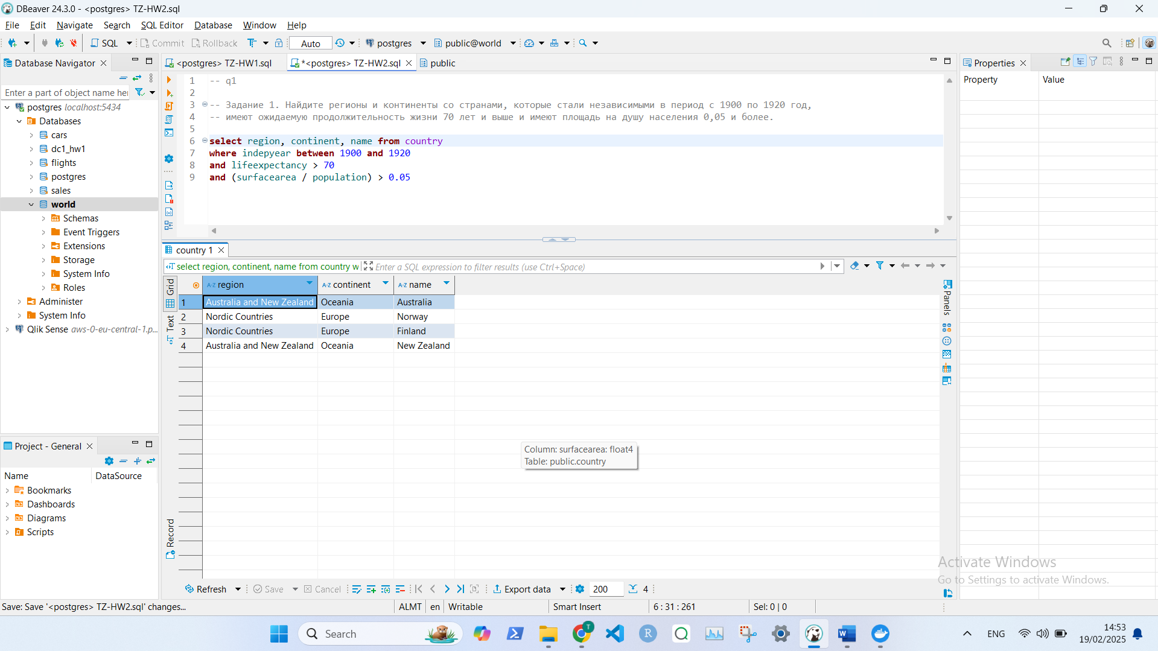

**Задание 2.**

*select name, localname from country*

*where name <> localname*

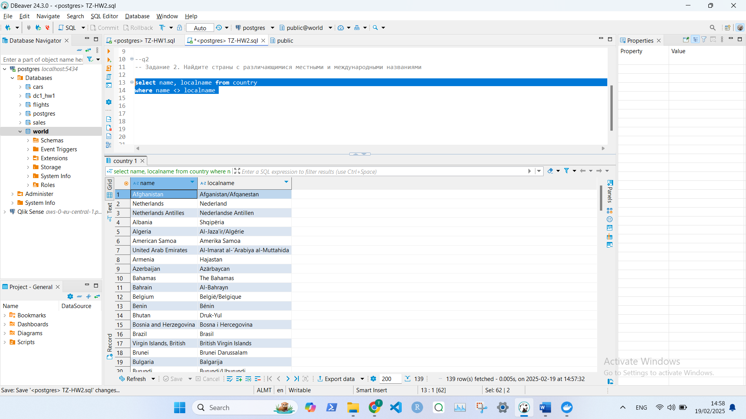

**Задание 3.**

*select distinct on (continent) continent, name, population, surfacearea*

*from country*

*where population > 0*

*order by continent, population DESC;*

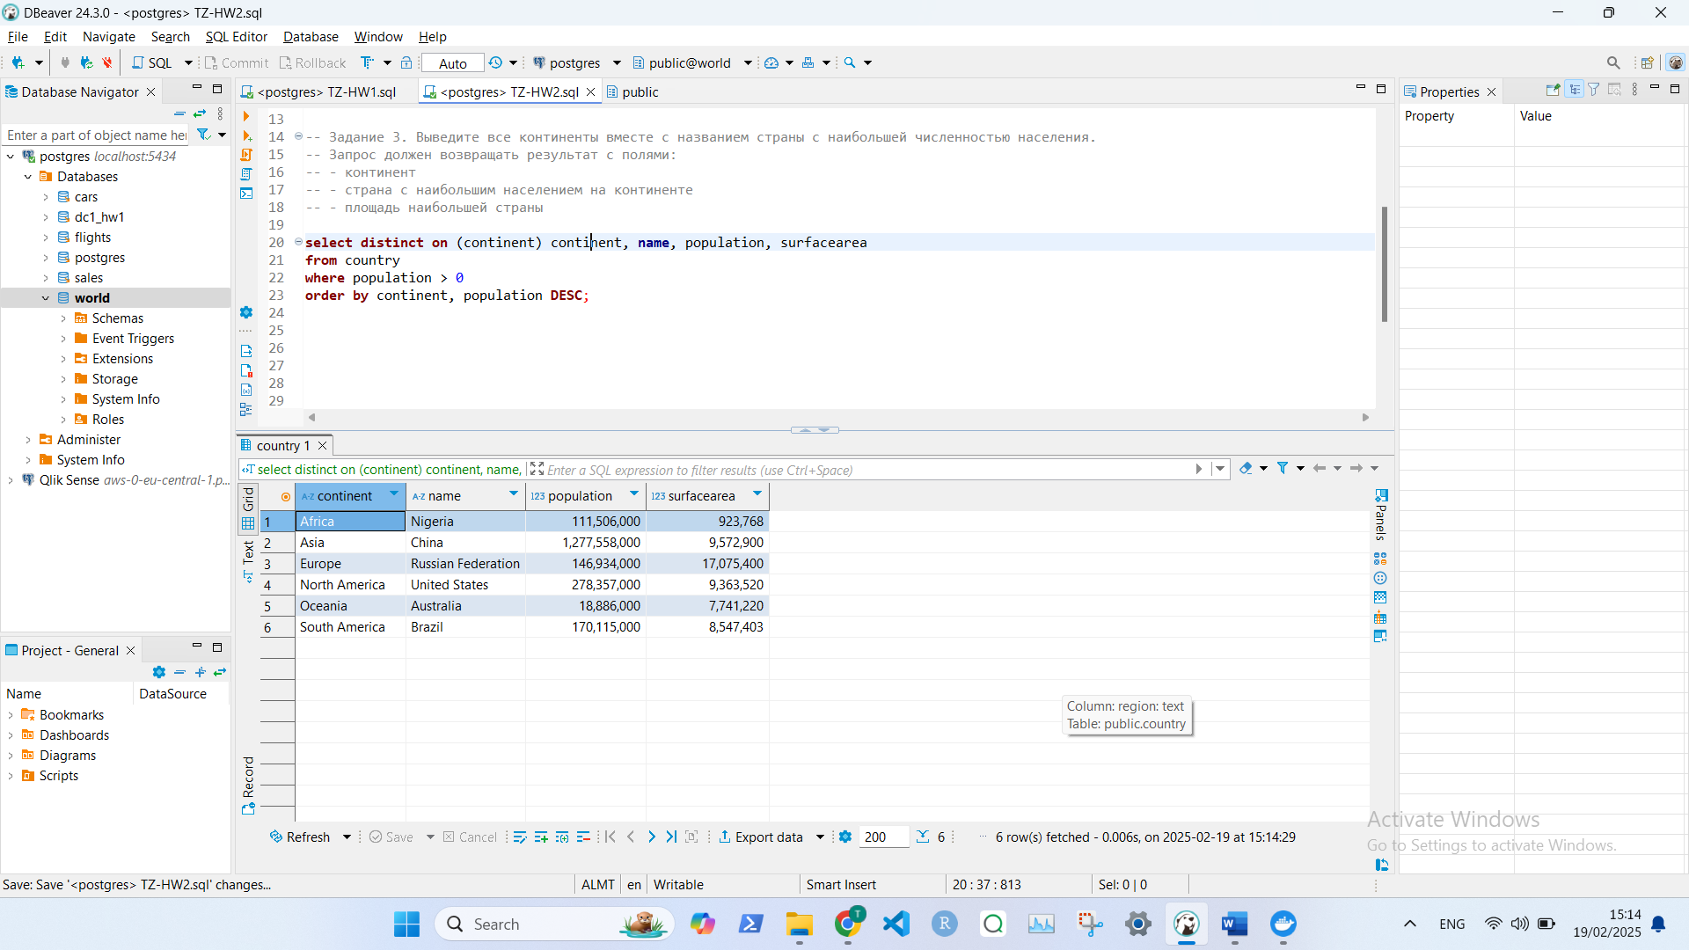

**Задание 4.**

*select distinct governmentform from country*

*where lifeexpectancy < 61*

*and continent in ('Asia', 'Europe')*

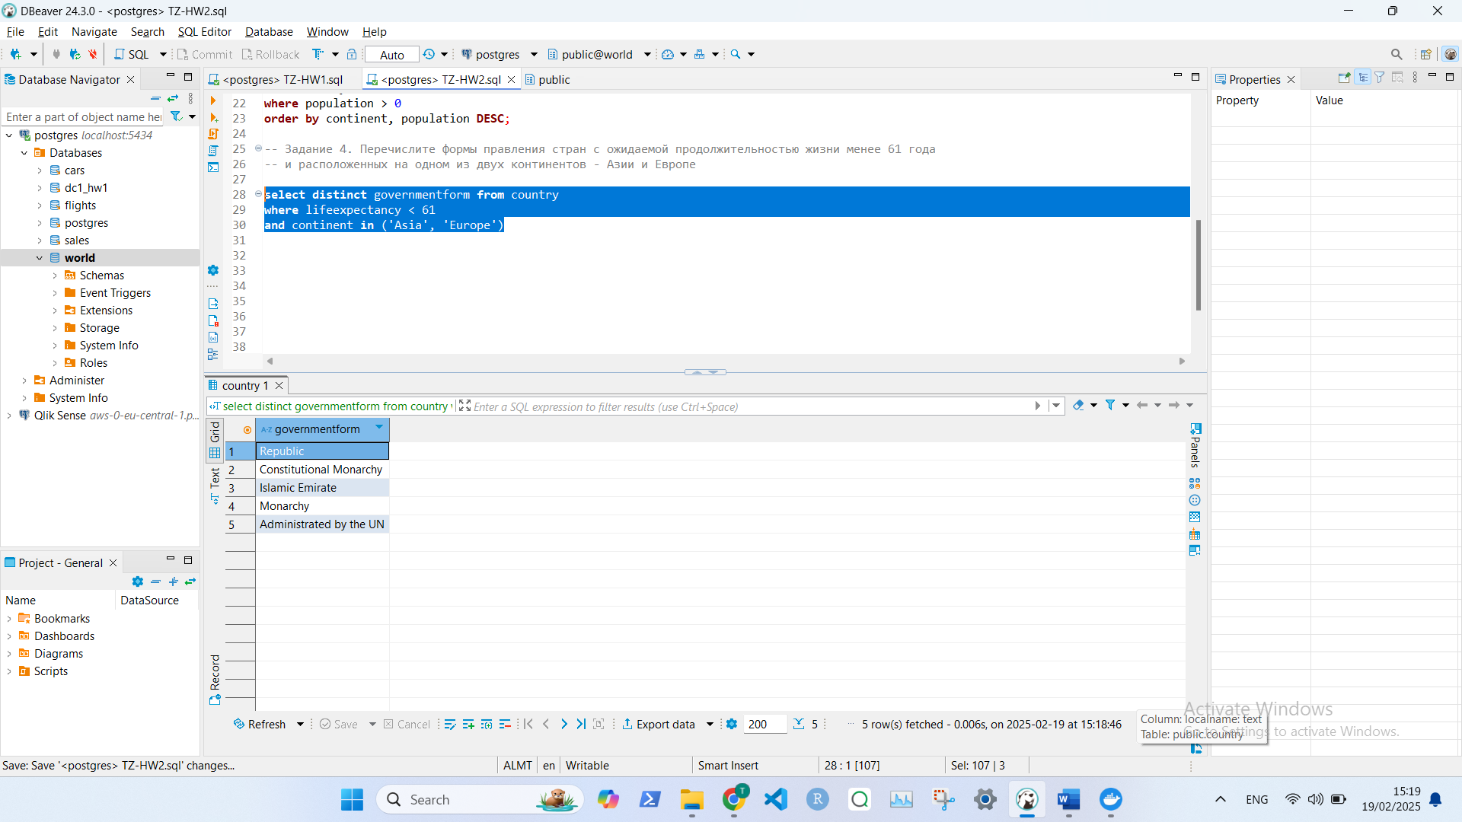

**Задание 5.**

*select name, code*

*from country*

*where name ilike '%' || code || '%';*

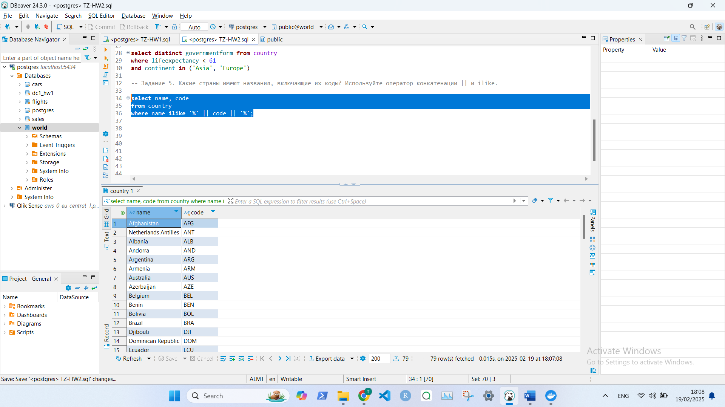**Задание 6.**

*select flight_id, extract(epoch from (actual_arrival - actual_departure)) / 60 as minutes*

*from bookings.flights*

*where departure_airport = 'DME'*

*and actual_departure > '2017-02-20 15:00:00.000 +0300' :: timestamp*

*and actual_departure < '2017-02-20 18:00:00.000 +0300' :: timestamp*

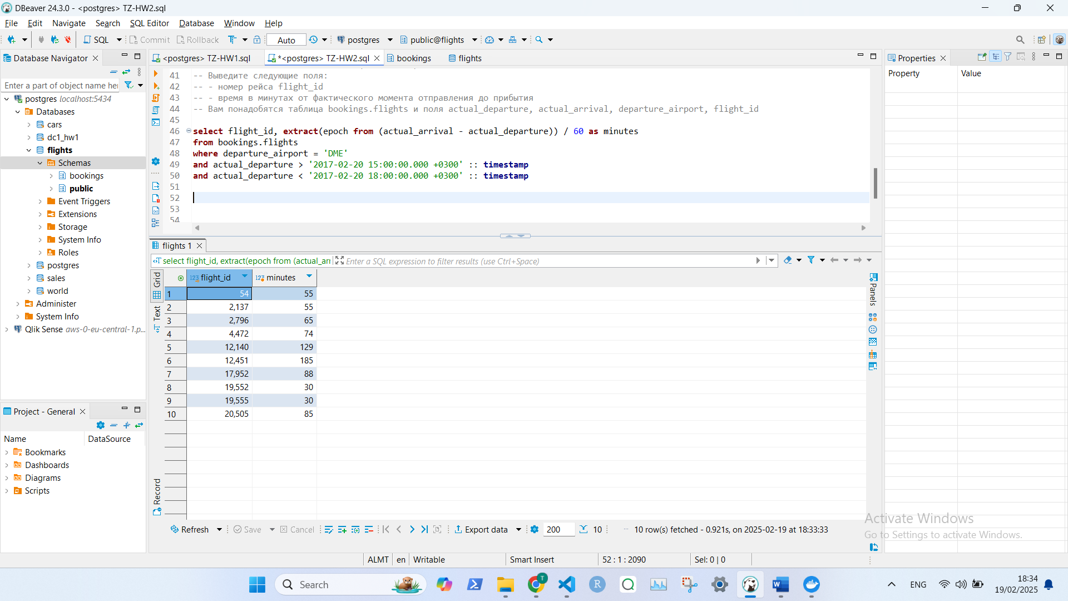

**Здание 7.**

*select c.code, c.name, c2.language, c2.isofficial, c2.percentage,*

*round(c.population * c2.percentage/100) as people_speak*

*from country c*

*left join countrylanguage c2*

*on c.code = c2.countrycode*

*where percentage > 30*

*order by name, isofficial desc*

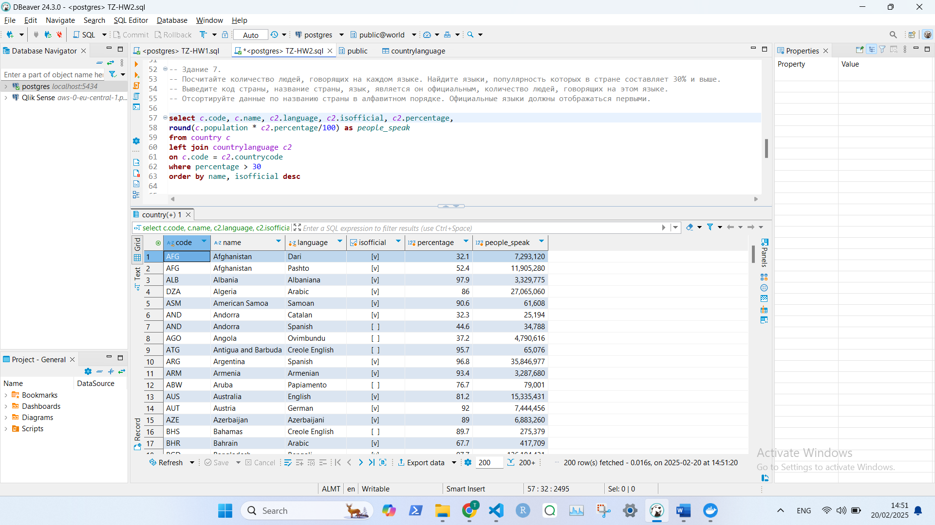

**Запрос 8.**

*select c2.name, c2.population*

*from country c*

*left join city c2*

*on c.code = c2.countrycode*

*-- and c.capital = c2.id -- кажется нужно только для столиц*

*left join countrylanguage c3*

*on c.code = c3.countrycode*

*where language = 'English'*

*and c2.name is not null*

*and c3.percentage > 0*

*order by c2.population desc*

*limit 10*

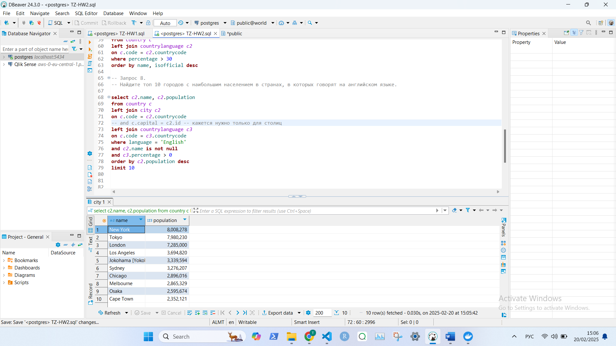

**Запрос 9.**

*with temp_table as (select distinct name as geo_name, 'Страна' as geo_type from country*

*union*

*select distinct continent as geo_name, 'Континент' as geo_type from country*

*union*

*select distinct region as geo_name, 'Регион' as geo_type from country)*

*select left(geo_name, 1) as first_letter, geo_name, geo_type*

*from temp_table*

*order by first_letter asc*

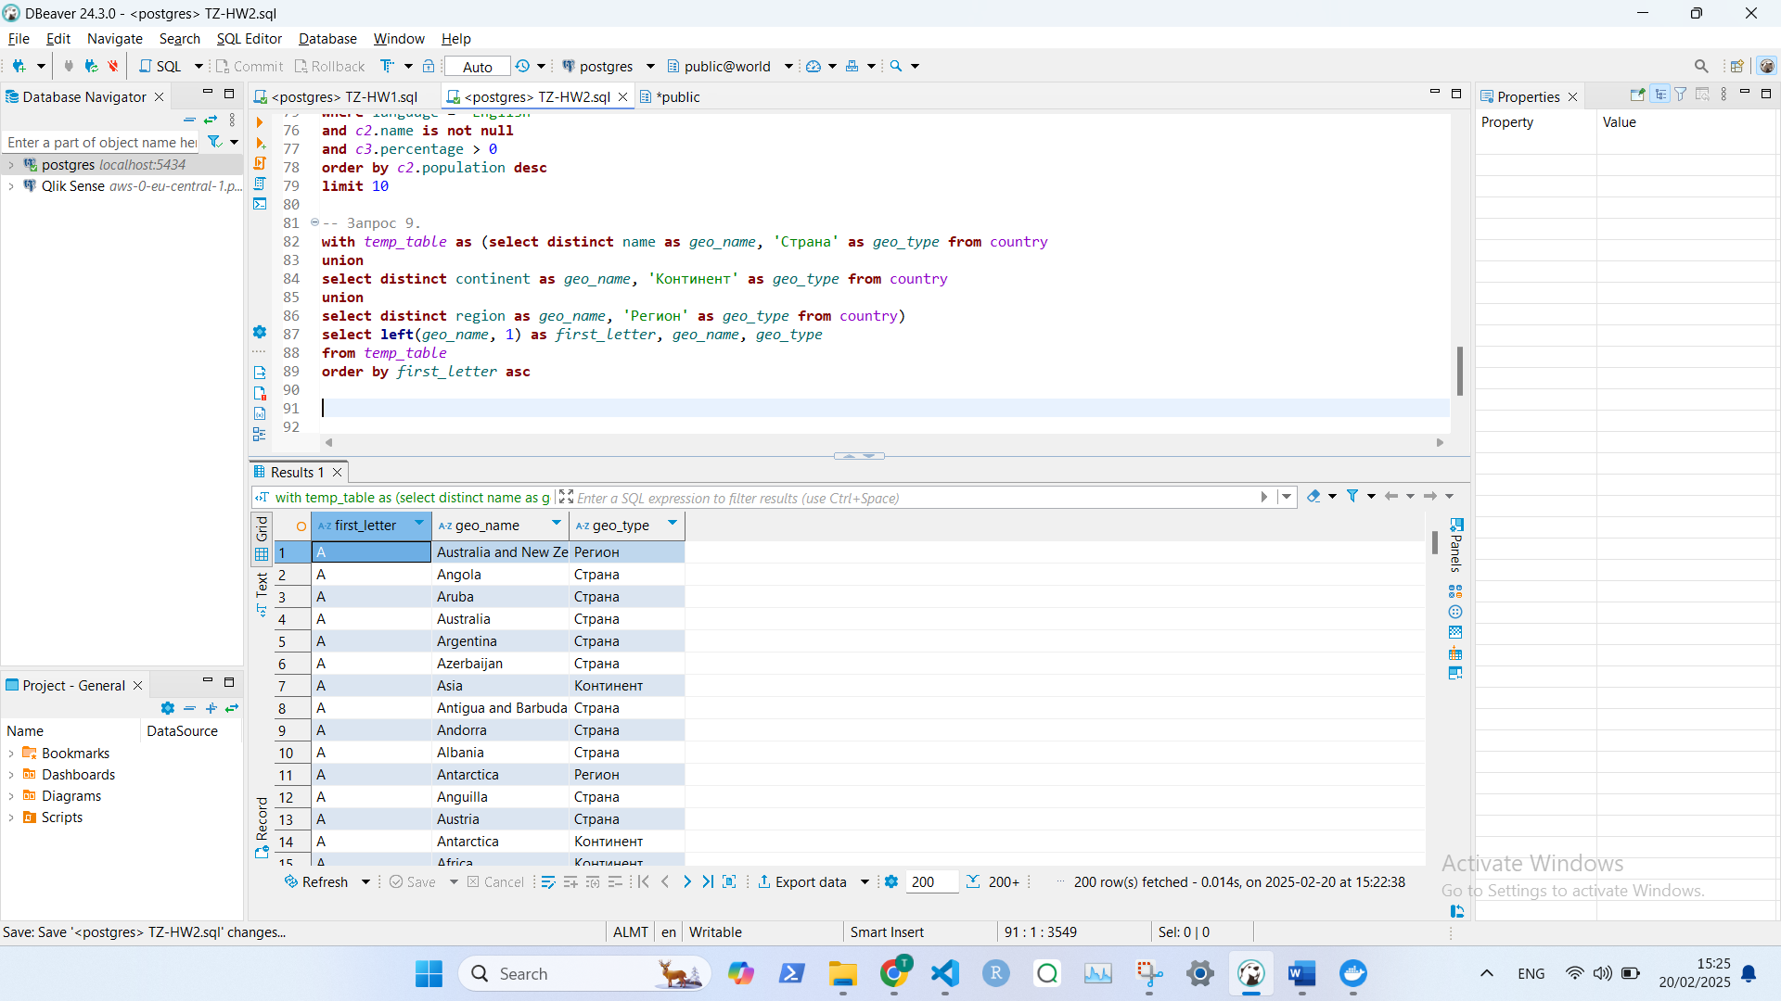

**Запрос 10**

*with*

*capitals_table as (*

*select c.name as country_name,*

*c2.name as capital_name, c2.population as capital_population*

*from country c*

*left join city c2*

*on c.code = c2.countrycode*

*and c.capital = c2.id),*

*city_table as*

*(select continent, c.name as country_name,*

*c2.name as city_name, c2.population as city_population*

*from country c*

*left join city c2*

*on c.code = c2.countrycode*

*and c.capital <> c2.id)*

*select continent, capitals_table.country_name, capital_name, capital_population, city_name,*

*city_population, cast(city_population AS FLOAT) / capital_population AS ratio*

*from*

*capitals_table right join city_table*

*on capitals_table.country_name = city_table.country_name*

*order by continent, city_name*

